Chapter 8: Subsidence and Soil Expansion and Contraction

Subsidence – a slow or rapid, nearly vertical, downward movement of Earth’s surface

* Not usually life threatening, but is one of the most widespread and costly natural hazards

Karst – landscape resulting from the dissolution of limestone, dolostone, marble, gypsum or rock salt

* Common type of landscape associated with subsidence
* Rocks are dissolved by surface water or ground water
* Dissolution produces voids which join to form caves and sinkholes
* Karst plain - A surface pockmarked with a large number of sinkholes

Soil expansion and contraction results from:

* Changes in the water content of soil
* Freezing and thawing

Solution sinkholes – pits formed by dissolution of buried bedrock along planes and fractures

Collapse sinkholes – collapse of surface or near surface rock or sediment

Cave systems – formed when dissolution produces a series of caves

* Related to a fluctuating groundwater table
* Groundwater seepage will deposit calcium carbonate on the sides, floors, and ceiling of the cave as flowstone, stalagmites and stalactites

Tower karst – large, steep limestone pillars that rise above the surrounding landscape

* Created in highly eroded karst regions

Disappearing Stream – streams that flow from the surface into cave openings

Springs – natural discharges of groundwater at the surface

* Vulnerable to contamination

Permafrost – permanently frozen ground

* Soil or rock must remain cemented with ice for atleast 2 years
* More than half of Canada is underlain by permafrost

Continuous permafrost – mean annual temp is less than -5o

Discontinuous permafrost – covers 50-90% of the landscape in an area and the mean annual temperature is between -4o and -2o

Spordic permafrost – covers less than 50% of the landscape in an area and the mean annual temperature is between -2o and 0o

The active layerof permafrost thaws in spring and refreezes in fall

* When permafrost thaws, it can create land subsidence
* Extensive thawing creates uneven soil called thermokarst

Frost susceptible sediments expand when they freeze and causes frost heaving

* When they freeze, 9% increase in volume occurs when water changes to ice
* Frost heaving – with the volume increase, there is an upward movement of sediment particles and the land surface

Piping

* Particles of silt and sand in the subsurface slowly carried by groundwater laterally to a spring
* Caused my groundwater creating tunnels as it percolates through loose sediments
* Common in silt and sand sediments
* Over time, shallow subterranean tunnels and cavities may develop to produce surface depressions and ravines

Sediment Compaction

* Fine sediments – clay, slit and sand commonly contain abundant pore water – water occupying spaces among the particles that constitute sediment
  + Over time amount of pore water decreases and the sediment compacts
  + Common on river deltas
* Collapsible sediments – windblown slit deposits (known as loess) and some stream deposits in arid regions are loosely bound or water soluble
  + Infiltrating water weakens bonds causing sediment to compact
* Organize sediments – accumulate in marshes, bogs, swamps and other wetlands
  + Contain large amounts of water and partially decayed leaves, roots and moss
  + When water is drained or soil is decomposed, these soils compact

Expansive Soils

* Expand during wet periods and shrink during dry periods
* Common in clay, shale, and clay rich soul containing smectite
* Can produce desiccation cracks
* Tilting and cracking of blocks of concrete and wavy bumps in asphalt can cause structural damage

Earthquakes and Deflation of Magma Chambers

* Can lower the ground surface over large areas
* Coastal subsidence can cause flooding
* The outer coasts of Vancouver island, Washington and Oregon have repeatedly been lowered by earthquakes
* Magma uplifts the volcano during an eruption
* The chamber empties after an eruption and surface subsides

Regions at risk

* Landscapes underlain by soluble rocks, permafrost, or easily compacted sediment
* Soils that contain abundant smectite clay are susceptible to shrinking and selling soils
* Soils containing silt are susceptible to frost heaving

Sinkhole formation

* Can cause considerable damage on highways, homes and sewage lines
* Triggered by fluctuations in the water table

Groundwater use and contaminations

* Caves provide direct connections between surface and ground water
* Groundwater can be vulnerable to pollution
* Water table can be significantly lower during droughts

Permafrost thaw

* Melting of permafrost has caused road to cave in, airport runways to fracture, railroad tracks to buckle and building to crack, tilt or collapse

Coastal Flooding and Loss of Wetlands

* Along the mississipi delta, this has contributed to the sinking of new Orleans
* Wetland that protect the city from surges are disappearing

Soil Volume Changes

* swelling of expansive soils and frost heaving
* causes billion of dollars in damage annually in north America

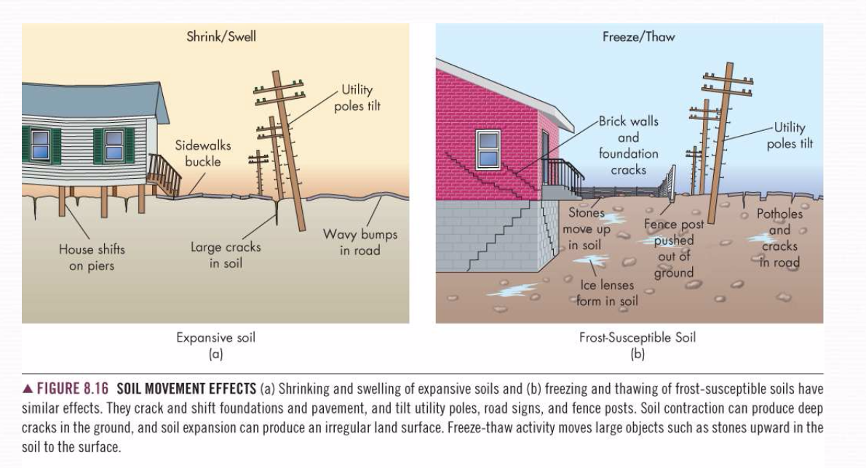

Links to other natural hazards

* subsidence can be an effect of earthquakes, volcanic activity and climate change
  + climate change can add to the drying of soils and the altering of the ground water table
* subsidence may cause flooding
  + overpumping of groundwater

Natural Service functions

* water supply – karst regions contain the world’s most abundant water supply
* aesthetic and scientific research – caves and karst landscapes are scenic areas that attract tourists and provide research for scientists
* unique ecosystems

Human Interaction with subsidence

* withdrawal of fluids – pumping oils, natural gas, or ground water decreases fluid pressure cause rocks and sediments to subside
* underground mining
  + coal mone structures have collapses
  + water is used to dissolve and pump out salt, leaving behind cavaties
* permafrost thaw
  + poorly insulated building directly on frozen ground
  + burial of warm utility lines
* restricting deltaic sedimentation
  + construction of dams, levees or canals
* draining wetlands
* landscaping on expansive soils
  + adding or removing plants changes water levels, contributing to shrinking and swelling soils

Minimize subsidence hazards

* restricting fluid withdrawal
  + preventing oil and groundwater extraction
  + injection wells add water when oil is pumped
* regulating mining
* preventing damage from thawing permafrost
* reducing damage from deltaic subsidence
* stopping the draining of wetlands
  + proper water mgmt. of existing marshes and swamps
* preventing damage from expansive soils
  + design of subsurface drains, rain gutters and foundations
  + construct building on a layer of compacted fill